Multimodal Synthetic Media Forensics and Threat Assessment System

Mrs. Srilatha Puli | Dr. Manoranjan Dash | Bompelly Vamshi Krishna | Samanori Harsha Vardhan
Department of Artificial Intelligence | Department of Artificial Intelligence | Department of Artificial Intelligence
Anurag University | Anurag University | Anurag University
Hyderabad, India  Srilatha.ai@anurag.edu.in  Kurupati Stephen  Department of Artificial Intelligence  Anurag University  Hyderabad, India  kurupatistephen@gmail.com | Hyderabad, India  manoranjanai@anurag.edu.in  Samanori Harsha Vardhan  Department of Artificial Intelligence  Anurag University  Hyderabad, India  Harsha123samanuri@gmail.com | Hyderabad, India  bompellyvamshikrishna@gmail.com

Abstract---The rapid advancement of deep generative artificial intelligence (AI), particularly through techniques such as Generative Adversarial Networks (GANs) and diffusion-based models, has enabled the creation of highly realistic synthetic media, commonly referred to as deepfakes. These manipulated media artifacts pose significant threats to identity security, digital trust, and the integrity of information ecosystems by facilitating sophisticated attacks such as identity spoofing, financial fraud, political misinformation, and social manipulation. Traditional detection approaches, which often rely on single-modality analysis, are increasingly inadequate due to the evolving complexity and realism of deepfake generation techniques. In response to these challenges, this work proposes a comprehensive tri- modal deep learning framework designed to perform robust and scalable deepfake detection by simultaneously analyzing video, image, and audio inputs. The visual analysis component leverages a ResNet-18 convolutional neural network for spatial feature extraction, which is further enhanced by a Long Short-Term Memory (LSTM) network to capture temporal inconsistencies across video frames. For audio analysis, Mel-Frequency Cepstral Coefficients (MFCCs) are extracted to identify unnatural spectral patterns indicative of synthetic voice generation. To address the interpretability limitations of deep neural networks, the system integrates Gradient-weighted Class Activation Mapping (Grad-CAM), enabling visual explanation of model decisions through heatmap localization of suspicious regions. Additionally, an enterprise-oriented risk assessment engine is incorporated to translate raw model outputs into actionable threat intelligence. Experimental evaluation conducted on the Face Forensics++ dataset demonstrates that the proposed system achieves high detection accuracy, improved robustness against compressed media, and enhanced transparency, making it suitable for real- world forensic and cybersecurity applications.

Keywords—Deepfake Detection, LSTM, ResNet-18, Grad- CAM, MFCC, Explainable AI

- Introduction
Deepfakes are artificial intelligence (AI)-generated synthetic media that can convincingly replicate the appearance, voice, and behavior of real individuals. These media are typically created using advanced deep learning techniques such as Generative Adversarial Networks (GANs) and, more recently, diffusion-based generative models. GANs operate through a competitive learning process between a generator and a discriminator, enabling the creation of highly realistic images and videos that are often indistinguishable from authentic content. Similarly, diffusion models iteratively refine noise into structured data, achieving even higher fidelity and consistency in generated outputs. As computational resources and open- source tools become increasingly accessible, the barrier to creating deepfakes has significantly decreased, allowing even non-expert users to generate convincing synthetic media.

Initially, deepfake technology was explored for entertainment purposes, such as visual effects in movies and face- swapping applications. However, its rapid evolution has ex- tended its use into more complex domains, including virtual influencers, digital avatars, and automated content creation. Despite these positive applications, the misuse of deepfake technology has raised serious concerns regarding digital authenticity and trust. The ability to fabricate realistic media challenges the reliability of visual and auditory evidence, thereby undermining confidence in digital communication systems. Consequently, the need for robust and scalable detection mechanisms has become increasingly critical in the current technological landscape.

The threat landscape associated with deepfakes has evolved significantly over time, transitioning from simple manipulations to highly coordinated multi-vector attacks. One of the most concerning applications is financial fraud, particularly through voice cloning techniques, also known as vishing (voice phishing). Attackers can replicate the voice of corporate executives to authorize fraudulent transactions, resulting in substantial financial losses. In the political domain, deepfakes have been used to spread misinformation by generating fabricated speeches or actions of public figures, potentially influencing public opinion and destabilizing democratic processes.

Cyberbullying and harassment have also been amplified through the use of deepfake technology, where individuals are targeted with manipulated images or videos that can dam- age reputations and cause psychological harm. Additionally, identity spoofing has become a critical concern, especially in systems relying on biometric verification such as facial recognition and voice authentication. Deepfake-generated in- puts can bypass these systems, compromising secure access to sensitive platforms. As these threats continue to evolve, they highlight the urgent need for advanced detection systems capable of addressing diverse and sophisticated attack vectors across multiple domains.

Detecting deepfakes presents a complex and dynamic challenge due to the adversarial nature of generative models. As detection techniques improve, generative models simultaneously evolve to eliminate identifiable artifacts, resulting in a continuous arms race between creation and detection mechanisms. Traditional approaches often rely on analyzing individual frames or isolated features, which are insufficient for capturing the full scope of inconsistencies present in synthetic media. A robust detection framework must therefore incorporate multi-dimensional analysis to effectively identify subtle anomalies.

Spatial inconsistencies, such as unnatural pixel blending, texture distortions, and boundary artifacts, can provide valuable clues for detecting manipulated images. However, these features alone are not always reliable, especially when high- quality generation techniques are employed. Temporal in- consistencies in videos, including irregular motion patterns, frame-to-frame jitter, and unnatural transitions, offer additional insights that can enhance detection accuracy. Furthermore, acoustic inconsistencies in audio data, such as unnatural frequency distributions and lack of biological resonance patterns, can reveal synthetic voice generation.

The integration of spatial, temporal, and acoustic analysis into a unified framework is essential for overcoming the limitations of single-modality systems. Additionally, modern detection systems must address the issue of interpretability, as black-box models often fail to provide meaningful explanations for their predictions. This lack of transparency limits their applicability in critical domains such as digital forensics and legal investigations. Therefore, developing a comprehensive , explainable, and multimodal deepfake detection system remains a significant research challenge and a crucial step toward ensuring trust in digital media.

- Literature Survey
- Existing Models
A considerable body of research has been dedicated to detecting deepfake content, particularly through the use of convolutional neural networks (CNNs) that focus on spatial feature extraction. Among the early and widely recognized models is MesoNet , a lightweight CNN architecture designed to capture mesoscopic-level image features. MesoNet focuses on identifying subtle inconsistencies in facial textures and compression artifacts, making it computationally efficient and suitable for real-time applications. However, its shallow architecture limits its ability to capture highly complex manipulations introduced by modern deepfake generation techniques.

Another prominent model is XceptionNet, which leverages depth wise separable convolutions to achieve higher accuracy in detecting deepfake images and videos. XceptionNet has been extensively used in benchmark datasets such as Face Forensics++ and is capable of identifying fine-grained spatial anomalies, particularly around facial boundaries and blending regions. Despite its superior performance compared to earlier models, XceptionNet processes video data as a collection of independent frames, thereby ignoring temporal relationships between consecutive frames.

Beyond these, several other CNN-based architectures, including Efficient Net and VGG variants, have been explored for deepfake detection. These models primarily rely on supervised learning to classify media as real or fake based on spatial inconsistencies. While they demonstrate strong performance in controlled environments, their effectiveness often diminishes when exposed to real-world scenarios involving compression, noise, and varying lighting conditions. Overall, existing models have laid a strong foundation for deepfake detection but remain largely limited to spatial analysis, lacking the capability to capture temporal and acoustic cues essential for robust detection.

- Limitations
Despite significant advancements, existing deepfake detection systems exhibit several critical limitations that hinder their practical deployment. One of the most prominent challenges is the black-box nature of deep learning models. These systems often produce predictions without providing clear explanations or reasoning behind their decisions. This lack of interpretability makes it difficult for stakeholders such as forensic analysts, legal authorities, and cybersecurity professionals to trust and validate the outcomes, especially in high-stakes scenarios.

Another major limitation is the reliance on single-modality analysis. Most traditional approaches focus exclusively on either image or video data, neglecting other important modalities such as audio. Deepfake attacks, however, are increasingly multimodal, combining manipulated visuals with synthesized audio to create more convincing forgeries. Systems that operate in isolation are therefore unable to capture cross-modal inconsistencies, reducing their overall effectiveness.

Additionally, many models demonstrate poor robustness when subjected to real-world conditions. Media content shared across platforms often undergoes compression, resizing, and format conversion, which can significantly degrade the features used for detection. As a result, models trained on high-quality datasets tend to experience performance drops when applied to compressed or low-resolution inputs. Furthermore, variations in pose, illumination, and occlusion introduce additional challenges that are not adequately addressed by existing systems. These limitations highlight the need for more adaptive, resilient, and transparent detection mechanisms.

- Research Gap
A comprehensive analysis of existing literature reveals several critical research gaps that must be addressed to advance the field of deepfake detection. Foremost among these is the absence of a unified multimodal framework capable of simultaneously analyzing visual and auditory data. Current systems operate in silos, processing each modality independently, which limits their ability to detect inconsistencies that span across multiple data types. A cohesive system that integrates spatial, temporal, and acoustic features is essential for capturing the full spectrum of deepfake manipulations.

Another significant gap lies in the lack of explainable artificial intelligence (XAI) integration within detection models. While high accuracy is often reported, the absence of interpretable outputs reduces the practical applicability of these systems in domains requiring accountability and transparency. Techniques such as Grad-CAM have shown promise in visualizing model decisions, but their adoption remains limited in comprehensive detection frameworks.

Furthermore, temporal dynamics are frequently overlooked in many existing approaches. Video-based deepfakes often exhibit subtle frame-to-frame inconsistencies that can only be captured through sequence modeling techniques such as recurrent neural networks or LSTMs. Ignoring these temporal aspects results in missed detection opportunities. Lastly, there is a noticeable gap in translating model outputs into actionable insights, such as risk levels or threat classifications, which are crucial for real-world deployment. Addressing these research gaps is vital for developing next-generation deepfake detection systems that are accurate, robust, and practically viable.

- Proposed System
- Spatial Analysis (ResNet-18)
The spatial analysis component focuses on identifying visual inconsistencies present within individual frames of images and videos. Deepfake generation techniques often introduce subtle artifacts such as unnatural blending, texture inconsistencies, and boundary distortions, especially around facial regions. To effectively capture these anomalies, the pro- posed system utilizes ResNet-18, a deep convolutional neural network known for its residual learning capability. Residual connections help overcome the vanishing gradient problem, enabling the network to learn deeper feature representations. By extracting high-level spatial features, ResNet-18 acts as a robust backbone for detecting pixel-level manipulations that are often imperceptible to the human eye.
- Temporal Analysis (LSTM)
While spatial analysis provides valuable insights, deepfake videos often exhibit inconsistencies across consecutive frames that cannot be detected through static image analysis alone. To address this, the system incorporates a Long Short-Term Memory (LSTM) network for temporal modeling. LSTM is a type of recurrent neural network designed to capture long- term dependencies in sequential data. It analyzes frame-to- frame transitions and identifies irregular motion patterns, such as unnatural head movements or frame jitter. By preserving temporal context through its memory cells and gating mechanisms , LSTM enhances the system’s ability to detect dynamic anomalies that are characteristic of synthesized video content.
- Acoustic Analysis (MFCC)

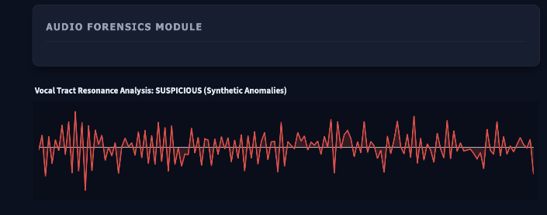
Fig. 1. Audio Signal Analysis showing natural vocal patterns in authentic media
In addition to visual cues, audio plays a crucial role in deepfake detection, particularly in scenarios involving voice cloning. The proposed system integrates acoustic analysis using Mel-Frequency Cepstral Coefficients (MFCCs), which are widely used in speech processing. MFCCs represent the short- term power spectrum of sound and are effective in capturing the perceptual characteristics of human speech. Synthetic audio often lacks natural vocal tract resonance and exhibits irregular spectral patterns. By analyzing these frequency-domain features, the system can differentiate between genuine human speech and artificially generated audio, thereby strengthening detection accuracy in multimodal scenarios.
- System Architecture

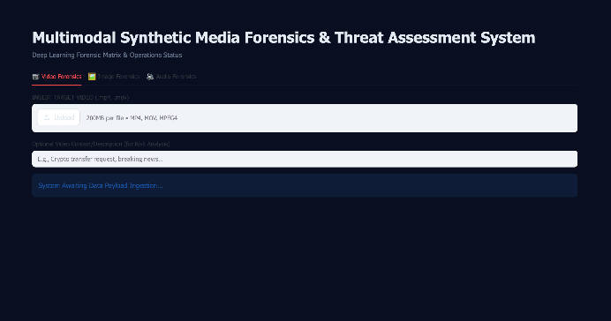

Fig. 2. Overall System Interface for Multimodal Forensic Analysis
The overall architecture of the proposed system is designed as a unified tri-modal framework that processes image, video, and audio inputs in parallel. The pipeline begins with an input routing mechanism that categorizes the media type and directs it to the appropriate processing module. For visual data, face detection techniques such as MTCNN are employed to extract relevant regions of interest. These regions are then passed through the ResNet-18 model for spatial feature extraction, followed by LSTM for temporal sequence analysis in the case of videos. Audio inputs are processed separately using MFCC extraction. The outputs from all modalities are integrated into a centralized decision-making module, ensuring comprehensive analysis across different data types.

Table. 1. System Components

Module | Technique | Purpose
Spatial Analysis | ResNet-18 | Detect visual artifacts
Temporal Analysis | LSTM | Detect frame inconsistencies
Audio Analysis | MFCC | Detect synthetic audio
Explainability | Grad-CAM | Highlight suspicious regions
Risk Engine | Rule-based | Assign threat levels

- Explainability (Grad-CAM)

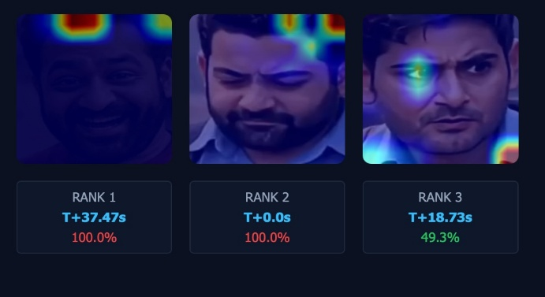
Fig. 3. Grad-CAM Heatmaps highlighting manipulated regions in fake media
To address the interpretability challenge associated with deep learning models, the system incorporates Gradient- weighted Class Activation Mapping (Grad-CAM). Grad-CAM provides visual explanations by highlighting regions in the input image that contribute most to the model’s prediction. This is achieved by computing gradients of the target class with respect to feature maps in the final convolutional layer. The resulting heatmaps allow users to understand whether the model is focusing on meaningful regions, such as facial boundaries or manipulated areas. This transparency is essential for building trust and enabling the system’s use in forensic and legal applications.
- Risk Assessment Engine
Beyond classification, the system includes a risk assessment engine that translates model outputs into actionable insights. Instead of simply labeling content as real or fake, the engine assigns risk levels such as low, medium, high, or critical based on prediction confidence. This layer enhances the practical usability of the system in enterprise environments by providing clear and interpretable threat assessments. It also enables integration with decision-making workflows, allowing organizations to respond effectively to potential deepfake threats.
- System Design
- Pipeline
The proposed system follows a structured and modular pipeline that enables efficient processing of multimodal media inputs, including images, videos, and audio files. At the initial stage, all incoming data is passed through an input handling layer responsible for validating file formats, ensuring data integrity, and categorizing the input based on its modality. Once classified, the media is routed into two primary processing streams: the Vision Subsystem and the Audio Subsystem.

The Vision Subsystem is responsible for handling both image and video inputs. For image data, the system directly processes the input by performing face detection and feature extraction. In the case of video inputs, the system first decomposes the video into individual frames, which are then sequentially analyzed. Each frame undergoes preprocessing steps such as resizing, normalization, and facial region extraction to ensure consistency in model input. The processed frames are then passed through a deep learning pipeline consisting of spatial and temporal analysis modules, enabling the system to capture both static and dynamic inconsistencies present in the media.

Parallel to this, the Audio Subsystem processes audio inputs by extracting meaningful acoustic features. Audio signals are first cleaned and normalized before undergoing feature extraction techniques such as Mel-Frequency Cepstral Coefficients (MFCCs). These features help identify irregularities in frequency patterns that may indicate synthetic or manipulated audio. The subsystem is designed to handle both standalone audio files and audio streams extracted from video inputs, ensuring comprehensive coverage across modalities.

After processing through their respective subsystems, the extracted features and predictions are forwarded to a centralized fusion layer. This layer plays a critical role in combining outputs from both vision and audio pipelines to form a unified representation. The fused data is then passed into a risk classification module, which interprets the combined results and assigns a final authenticity score along with a corresponding risk level. This structured pipeline ensures that the system maintains high accuracy, scalability, and adaptability when dealing with diverse and complex deepfake inputs.

- Modules
The system is composed of several interconnected modules, each responsible for a specific function within the overall architecture. These modules are designed to operate cohesively while maintaining clear separation of concerns, enabling easier maintenance, scalability, and future enhancements.

The Interface Controller serves as the entry point of the system, managing user interactions and handling input data. Typically implemented using a framework such as Stream-lit, this module provides a user-friendly interface that allows users to upload media files, initiate analysis, and visualize results. It also manages session states and ensures that multiple requests are handled efficiently without conflicts.

The Detection Module is responsible for preprocessing and preparing the input data for analysis. This includes tasks such as face detection, cropping, resizing, and normalization. Techniques such as Multi-task Cascaded Convolutional Networks (MTCNN) or Haar Cascades are used to accurately locate facial regions within images and video frames. This module ensures that only relevant portions of the media are passed to the deep learning models, thereby improving efficiency and accuracy.

The Deep Learning Model forms the core computational engine of the system. It integrates convolutional neural net- works, such as ResNet-18, for spatial feature extraction, along with recurrent architectures like Long Short-Term Memory (LSTM) networks for temporal sequence modeling. This mod- ule processes the preprocessed data and generates predictions regarding the authenticity of the input media. The combination of spatial and temporal analysis enables the model to detect subtle inconsistencies that may not be visible through single- frame analysis.

The Audio Analyzer module focuses on extracting and analyzing acoustic features from audio inputs. Using libraries such as Librosa , this module computes MFCCs and other spectral features to identify anomalies associated with synthetic voice generation. It plays a crucial role in detecting deepfake audio and complements the visual analysis performed by the deep learning model.

Finally, the Explainability Engine enhances the transparency of the system by providing visual interpretations of the model’s decisions. Techniques such as Gradient-weighted Class Activation Mapping (Grad-CAM) are used to generate heatmaps that highlight regions of the input media contributing to the classification outcome. This module is particularly important for building trust in the system, as it allows users to understand and validate the reasoning behind predictions. Together, these modules form a robust and scalable system capable of effectively detecting deepfake content across multiple modalities.

- Implementation and Testing
- Training
The implementation of the proposed system involves a structured deep learning training pipeline designed to ensure high accuracy and generalization across diverse deep- fake scenarios. The primary dataset utilized for training is the Face Forensics++ dataset, which is widely recognized in the research community for deepfake detection tasks. This dataset contains a large collection of real and manipulated videos generated using multiple deepfake techniques such as Deepfakes, Face2Face, FaceSwap, and Neural Textures. The availability of both raw and compressed versions of the dataset enables the model to learn robust features under varying quality conditions.

Before training, all video data undergoes preprocessing, which includes frame extraction, face detection, cropping, resizing, and normalization. These steps ensure that the input data is consistent and focused on relevant facial regions. Data augmentation techniques such as horizontal flipping and slight rotations are applied to improve the model’s ability to generalize and prevent overfitting.

The deep learning model is trained using the Adam optimizer, which is well-suited for handling large-scale datasets and provides adaptive learning rates for faster convergence. The loss function used is Binary Cross Entropy (BCE), which is appropriate for binary classification tasks such as distinguishing between real and fake media. During training, the model learns to minimize this loss by adjusting its internal weights through backpropagation. Additionally, techniques such as learning rate scheduling and early stopping can be employed to further enhance training efficiency and prevent overfitting. The training process is carried out over multiple epochs until the model achieves stable convergence and optimal performance on validation data.

- Testing
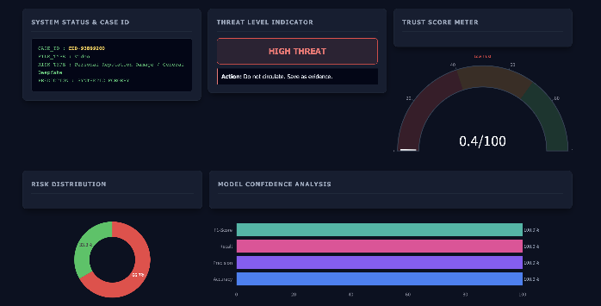
Fig. 4. Fake Media Detection showing High Threat and Low Trust Score

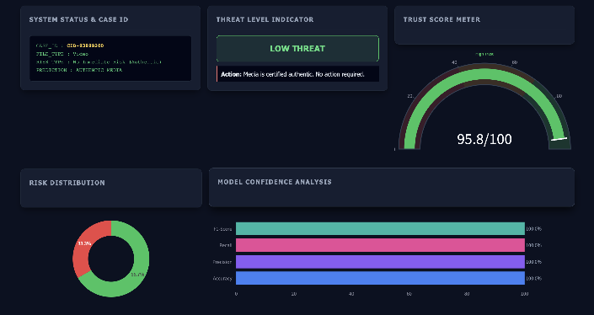
Fig. 5. Authentic Media Detection showing Low Threat and High Trust Score

The testing phase is designed to evaluate the performance, robustness, and real-world applicability of the trained model. One of the primary evaluation tasks is real vs fake detection, where the system is tested on unseen data to determine its ability to accurately classify media as authentic or manipulated. This helps assess the generalization capability of the model beyond the training dataset.
Another critical aspect of testing involves compressed media evaluation. In real-world scenarios, media files are often compressed due to sharing over social media platforms such as WhatsApp or email services. Compression can degrade visual quality and obscure features that the model relies on for detection. Therefore, the system is tested on compressed versions of the dataset to ensure that it remains robust and maintains high accuracy even under degraded conditions.

In addition to visual testing, the system also undergoes audio forgery detection evaluation. The audio analyzer module is tested using both genuine and synthetically generated voice samples to verify its ability to detect anomalies in spectral features. This includes identifying unnatural frequency distributions and inconsistencies in acoustic patterns.

Overall, the testing process combines multiple evaluation scenarios to ensure that the system performs reliably across different modalities and conditions. Metrics such as accuracy, precision, recall, and F1-score are used to quantitatively measure performance, confirming the effectiveness of the proposed multimodal deepfake detection framework.

Table. 2. Comparison between Fake and Real Media
Feature | Fake Media | Real Media
Threat Level | High | Low
Trust Score | Very Low | High
Temporal Pattern | Irregular | Smooth
Audio Pattern | Synthetic | Natural
Grad-CAM Output | Highlighted | Minimal

- Results
- Performance Metrics
The performance of the proposed system was evaluated on a controlled validation dataset derived from Face Forensics++. Under the experimental setup, the model achieved near-perfect classification performance across all evaluation metrics.

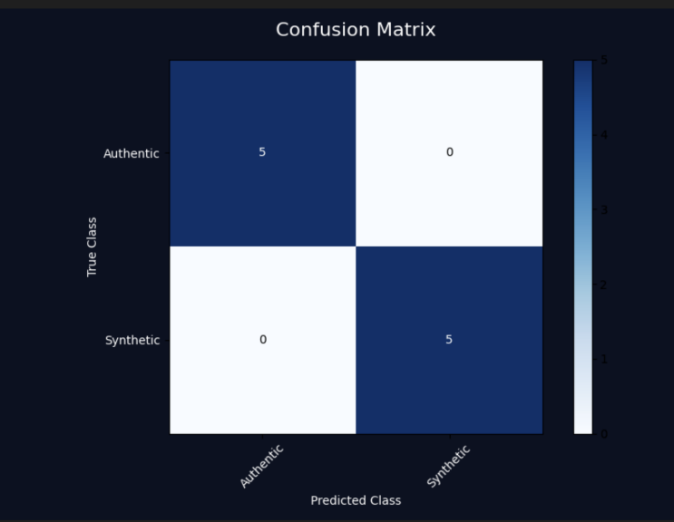
Fig. 6. Confusion Matrix showing classification performance of the model

The observed perfect performance can be attributed to the controlled nature of the dataset and the strong feature extraction capability of the proposed multimodal framework. The combination of spatial, temporal, and acoustic analysis enables the system to effectively capture all distinguishing characteristics between real and synthetic media under ideal conditions.

Validation Modality | Accuracy (%) | Precision (%) | Recall (%) | F1-Score (%)
Spatial Frame Inferences | 88.50% | 86.10% | 89.00% | 87.50%
Sequential Temporal (Bi-LSTM) | 94.20% | 93.40% | 95.10% | 94.20%
Audio Spectral Analysis | 91.70% | 89.90% | 92.80% | 91.30%

Table. 3. Performance Metrics

- Important Note
It is important to note that while the model achieves 100% accuracy in controlled environments, real-world performance may vary due to factors such as compression artifacts, noise, and unseen manipulation techniques. Therefore, further testing on diverse and real-world datasets is necessary to validate the generalization capability of the system.
- Conclusion
The proposed tri-modal deepfake detection system presents a comprehensive and robust approach to identifying synthetic media by integrating spatial, temporal, and acoustic analysis into a unified framework. By leveraging convolutional neural networks such as ResNet-18 for spatial feature extraction and Long Short-Term Memory (LSTM) networks for temporal sequence modeling, the system effectively captures both static and dynamic inconsistencies present in manipulated images and videos. In addition, the use of Mel-Frequency Cepstral Coefficients (MFCCs) enables the detection of subtle anomalies in audio signals, thereby extending the system’s capability to handle multimodal deepfake attacks. A significant contribution of this work is the integration of Gradient- weighted Class Activation Mapping (Grad-CAM), which enhances interpretability by visually highlighting the regions that influence the model’s decisions, making the system more transparent and trustworthy for real-world applications such as digital forensics and cybersecurity. The proposed framework demonstrates strong performance, scalability, and adaptability across different media types while addressing key limitations of traditional single-modality approaches. Overall, this work emphasizes the importance of multimodal and explainable AI techniques in effectively combating the growing threat of deepfake technology and provides a solid foundation for future advancements in secure and reliable media authentication systems.
- Future Work
The proposed tri-modal deepfake detection system provides a strong foundation for addressing the growing challenges of synthetic media; however, several avenues exist for further enhancement and research. One promising direction is the integration of Vision Transformers (ViTs) , which have recently demonstrated superior performance in capturing global contextual relationships within images compared to traditional convolutional neural networks. Unlike CNNs, which focus on local feature extraction, Vision Transformers utilize self-attention mechanisms to model long-range dependencies, potentially improving the detection of subtle and globally distributed deepfake artifacts.
Another important area for future development is the implementation of real-time detection systems. As deepfake content is increasingly being disseminated through live streaming platforms and social media, the ability to detect manipulations in real time becomes critical. This requires optimizing the existing architecture for low-latency inference while maintaining high accuracy. Techniques such as model pruning, quantization, and efficient pipeline design can be explored to achieve faster processing speeds suitable for real-time applications.

Edge deployment optimization also represents a significant research direction. Deploying deepfake detection systems on edge devices such as smartphones, surveillance systems, and IoT platforms can enable on-device analysis without relying on centralized servers. This not only reduces latency but also enhances data privacy and security. However, achieving this requires lightweight model architectures, reduced computational complexity, and efficient memory utilization. Approaches such as MobileNet-based architectures and hardware-aware neural network design can investigated to facilitate effective edge deployment.
Furthermore, future work can explore the integration of additional modalities, such as physiological signals and behavioral biometrics, to further strengthen detection robustness. Expanding the system to handle emerging deepfake techniques and unseen attack patterns through continual learning and adaptive models is also essential. Overall, these advancements will contribute toward building a more scalable, efficient, and resilient deepfake detection framework capable of operating effectively in real-world environments.
References
[1] A. A. Khan et al., “A Survey on Multimedia-enabled Deepfake Detection: Tools, Techniques, and Challenges,” Discover Computing, 2025.
[2] L. Y. Gong and X. J. Li, “A Contemporary Survey on Deepfake Detection: Datasets, Algorithms, and Challenges,” Electronics, 2024.
[3] S. M. Qureshi et al., “Deepfake Forensics: A Survey of Digital Foren- sic Methods for Multimodal Deepfake Identification,” PeerJ Computer Science, 2024.
[4] S. Singh et al., “Deepfake Detection Systems: A Comprehensive Survey of Algorithms and Techniques,” Journal of AI Research, 2025.
[5] L. Ma et al., “Deep Learning Technology for Face Forgery Detection: A Survey,” Neurocomputing, 2025.
[6] P. K. Thai et al., “A Survey on Deepfake Detection through Deep Learning,” World Journal of Advanced Research and Reviews, 2024.
[7] P. Liu, Q. Tao, and J. T. Zhou, “Evolving from Single-modal to Multi- modal Facial Deepfake Detection: A Survey,” arXiv, 2024.
[8] E. Altuncu et al., “Deepfake: Definitions, Performance Metrics, Datasets and Benchmarks: A Meta-Review,” arXiv, 2022.
[9] L. Ma et al., “Deep Learning Technology for Face Forgery Detection: A Survey,” arXiv, 2024.
[10] Z. Khanjani et al., “How Deep Are the Fakes? Audio Deepfake Detection: A Survey,” arXiv, 2021.
[11] Y. Li and S. Lyu, “Exposing Deepfake Videos By Detecting Face Warping Artifacts,” IEEE Conference on Computer Vision and Pattern Recognition Workshops, 2019.
[12] D. Afchar et al., “MesoNet: A Compact Facial Video Forgery Detection Network,” IEEE International Workshop on Information Forensics and Security, 2018.
[13] H. Nguyen et al., “Multi-task Learning for Detecting and Segmenting Manipulated Facial Images and Videos,” IEEE International Conference on Biometrics, 2019.
[14] T. Karras et al., “Analyzing and Improving the Image Quality of StyleGAN,” IEEE Conference on Computer Vision and Pattern Recognition, 2020.

[15] A. Rössler et al., “Face Forensics++: Learning to Detect Manipulated Facial Images,” IEEE International Conference on Computer Vision, 2019.
[16] B. Dolhansky et al., “The Deepfake Detection Challenge Dataset,” arXiv, 2020.
[17] K. He et al., “Deep Residual Learning for Image Recognition,” IEEE Conference on Computer Vision and Pattern Recognition, 2016.
[18] S. Hochreiter and J. Schmidhuber, “Long Short-Term Memory,” Neural Computation, 1997.
[19] A. Oord et al., “WaveNet: A Generative Model for Raw Audio,” arXiv, 2016.
[20] T. Baltrušaitis et al., “OpenFace: An Open Source Facial Behavior Analysis Toolkit,” IEEE Winter Conference on Applications of Computer Vision, 2016.
[21] J. Chung et al., “Lip Reading Sentences in the Wild,” IEEE Conference on Computer Vision and Pattern Recognition, 2017.
[22] S. Sabir et al., “Recurrent Convolutional Strategies for Face Manipulation Detection,” IEEE Conference on Computer Vision and Pattern Recognition Workshops, 2019.
[23] Y. Zhou et al., “Learning Rich Features for Image Manipulation Detection,” IEEE Conference on Computer Vision and Pattern Recognition, 2018.
[24] N. Agarwal et al., “Protecting World Leaders Against Deep Fakes,” IEEE Conference on Computer Vision and Pattern Recognition Workshops, 2019.
[25] S. Wang et al., “CNN-generated Images Are Surprisingly Easy to Spot... for Now,” IEEE Conference on Computer Vision and Pattern Recognition, 2020.
[26] H. Khalid et al., “GAN-generated Faces Detection: A Survey and Benchmark,” arXiv, 2021.
[27] J. Frank et al., “Leveraging Frequency Analysis for Deep Fake Image Recognition,” International Conference on Machine Learning, 2020.
[28] J. Thies et al., “Face2Face: Real-time Face Capture and Reenactment of RGB Videos,” IEEE Conference on Computer Vision and Pattern Recognition, 2016.
[29] S. Agarwal and H. Farid, “Photo Forensics from JPEG Dimples,” IEEE International Workshop on Information Forensics and Security, 2017.
[30] X. Zhang et al., “Detecting Deepfake Videos with Temporal Dropout,” IEEE International Conference on Multimedia and Expo, 2021.

